
PRODUCTIVE

Microsoft Dynamics Snap
Customer Journal Snap-in
For Microsoft Dynamics™ CRM 3.0 / 2007 Microsoft® Office system
Technical White Paper

February 10, 2007

Microsoft Dynamics Snap Sandbox

Table of Contents
EXECUTIVE SUMMARY 3
INTRODUCING MICROSOFT DYNAMICS SNAP 3
MICROSOFT DYNAMICS SNAP FOR CUSTOMER JOURNAL 3
FUNCTIONAL OVERVIEW 4
A 360º VIEW OF CUSTOMER 5
WORK OFFLINE 6
SYNCHRONIZING WITH MICROSOFT DYNAMICS CRM 8
HIGH LEVEL ARCHITECTURE 10
PRE-Requisites 11

EXECUTIVE SUMMARY
Many corporations implement business application systems like Microsoft Dynamics™ to automate their business processes. However, there are often times when employees are not able to connect directly with the system and yet still need access to the business essential data that resides within it. What if there were ways to enable those information workers to access the data in Microsoft Dynamics applications whenever and wherever they need it?

INTRODUCING MICROSOFT DYNAMICS SNAP
Microsoft Dynamics Snap applications do just that—they allow information workers to interact with Microsoft Dynamics business information, thereby increasing their productivity and enabling them to make decisions with confidence, all from within the Microsoft Office applications they are most comfortable with and with which they are most familiar. Now all employees can get timely and accurate data out of or into the Microsoft Dynamics applications without ever having to leave Microsoft Office. Microsoft Dynamics Snap applications help companies maximize their investment in Microsoft technology by delivering the power of the Microsoft Dynamics business applications to every single employee.

MICROSOFT DYNAMICS SNAP FOR CUSTOMER JOURNAL
The Customer Journal Snap-in enables a salesperson to have more productive sales meetings by allowing them to capture all the information he needs about a particular customer, take that information with him, view it and update it, all while remaining offline from the Microsoft Dynamics™ CRM system. It does this by capturing the customer information in a Microsoft Office InfoPath® 2007 form that pulls the data from Microsoft Dynamics CRM 3.0. This allows the salesperson to:
- Get a holistic view of a customer’s relationship with his company
- Add / Edit information in the InfoPath form
- Update the edits in Microsoft Dynamics CRM when reconnected

The Customer Journal Snap-in gives you the ability to capture vital data from the Microsoft Dynamics CRM system and then refer to it from within the Office environment when offline. This has many benefits. It helps you:
- Increase the productivity of meetings with customers providing access to important information when you need it
- Increase the accuracy of your records by allowing you to update them while offline
- Minimize duplication of effort and possible errors in data entry by allowing you to upload those changes when you are back online

Customer Journal Snap-in works with Microsoft Dynamics CRM 3.0 and Microsoft Office 2007 and is distributed at the Microsoft Dynamics Snap site on GotDotNet.com.
This white paper is divided into two sections, the first to help you understand the features of the Customer Journal Snap-in and the second to provide an overview of the technology used to help you create your own solutions:
- Functional overview: This section explains the Customer Journal Snap-in functionality.
- High level architecture and customization: This section explains the various technologies used and how they work together to provide the functionality. Partners may use a similar framework to build additional scenarios.

FUNCTIONAL OVERVIEW
A Sales professional spends a lot of time outside the office meeting with customers. Most of these meetings involve discussions around the on-going transactions with the customer and potential opportunities that may arise in the future. To optimize the time spent at these meetings, it is essential for the Salesperson to know as much as possible about the history of the relationship with the customer and the status of all on-going transactions. Additionally, any commitments he makes during his discussion with the customer need to be accurately recorded for future reference.
The Customer Journal Snap-in allows a Salesperson to quickly view and capture a 360º view of his organization’s relationship with a customer from data in the Microsoft Dynamics CRM system. Using a form created in Microsoft Office InfoPath 2007, he can take this data with him and view, add to or edit that data all while off of the network. Once back on the company network, he can easily update Microsoft Dynamics CRM.
The next few screenshots demonstrate how easy it can be for a Sales Rep to have all the information he needs at his fingertips, before, during and after the sales meeting with the customer. Consider a scenario where you are a salesperson preparing to leave for a meeting with a key account that you manage.

A 360º VIEW OF CUSTOMER
All that you need to do to get a complete summary of all recent interactions with the customer is to open the Microsoft Office InfoPath form, click Connect to CRM button, search for the customer by entering first few characters of his name in the Customer Account Name text box on the form and click Go.
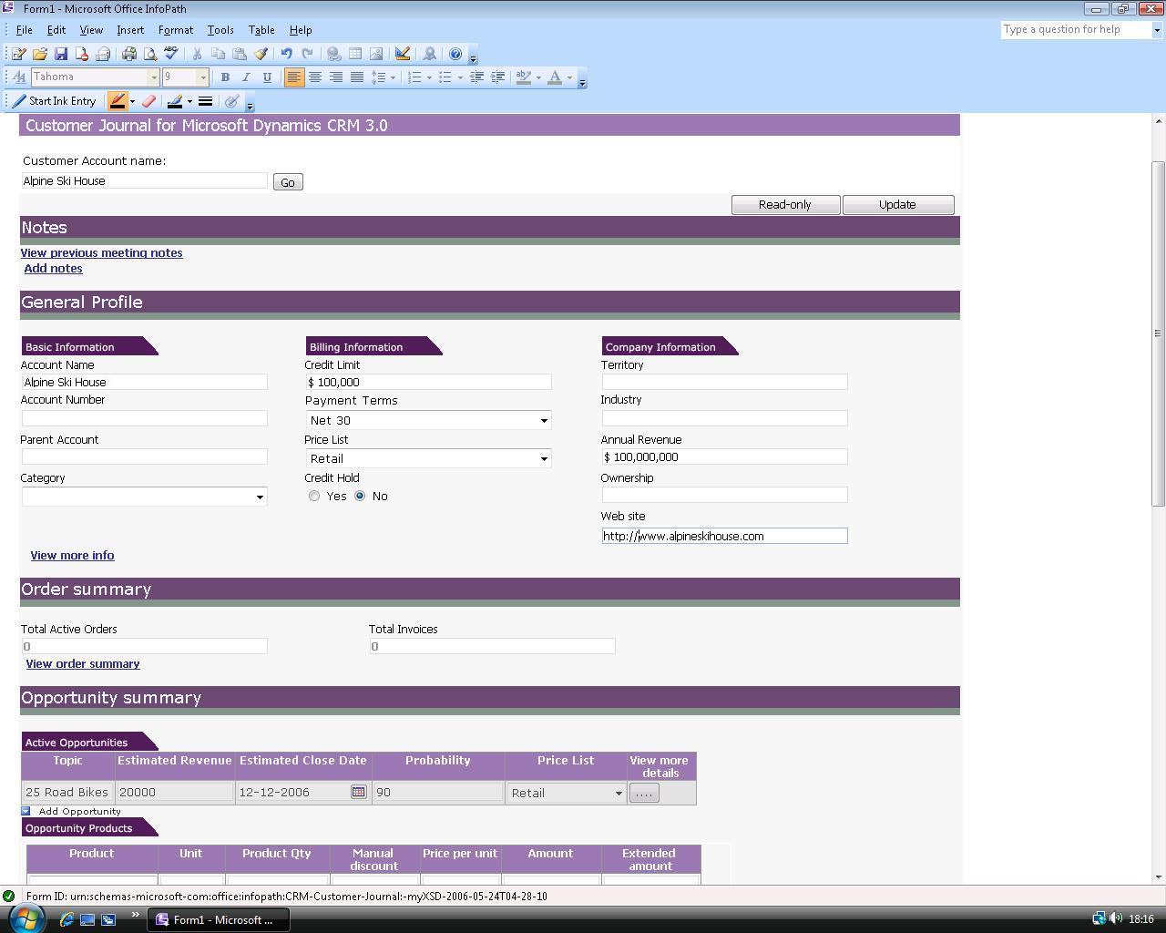
The fields on the InfoPath form will show data from Microsoft Dynamics CRM pertaining to the customer. The information available includes general profile data like account number, account details, general billing details, etc. to transactional information like currently active quotes and orders, last 5 wins and losses, recent service requests, etc.
View Details
Each section in the InfoPath form provides a summary view of a customer’s information. To view more details, click on the View more details button in each section. This will open the Microsoft Dynamics CRM web client in the web browser window with the details of the entity or transaction information. In the scenario where you are preparing for the customer meeting, this feature can provide quick access to the last quote attached to the customer record in Microsoft Dynamics CRM.

WORK OFFLINE
All you need to do to enable you to take this relevant information with you to the customer meeting is name the form and save it on your machine.
View Customer Information
Simply open the saved form to access the data during your meeting. There is no need to connect to your company’s Microsoft Dynamics CRM system.
Add and Edit Data
Click the Edit button on the form to make changes to data. Note that not all fields on the form can be edited. Non-editable fields are differentiated in appearance from the editable ones. You can make changes, save, close and re-open the form repeatedly as you access and edit information.
In our scenario, say customer you are meeting tells you about a new opportunity. To add this information to the form, go to the Opportunity summary section and click on the Add opportunity button while the form is in Edit mode. This adds a new blank row to the Active opportunities table. Fill it with appropriate values. To add further details about products or services comprising the opportunity, click the row corresponding to the opportunity and then click on the Add product button in the Opportunity Products grid.
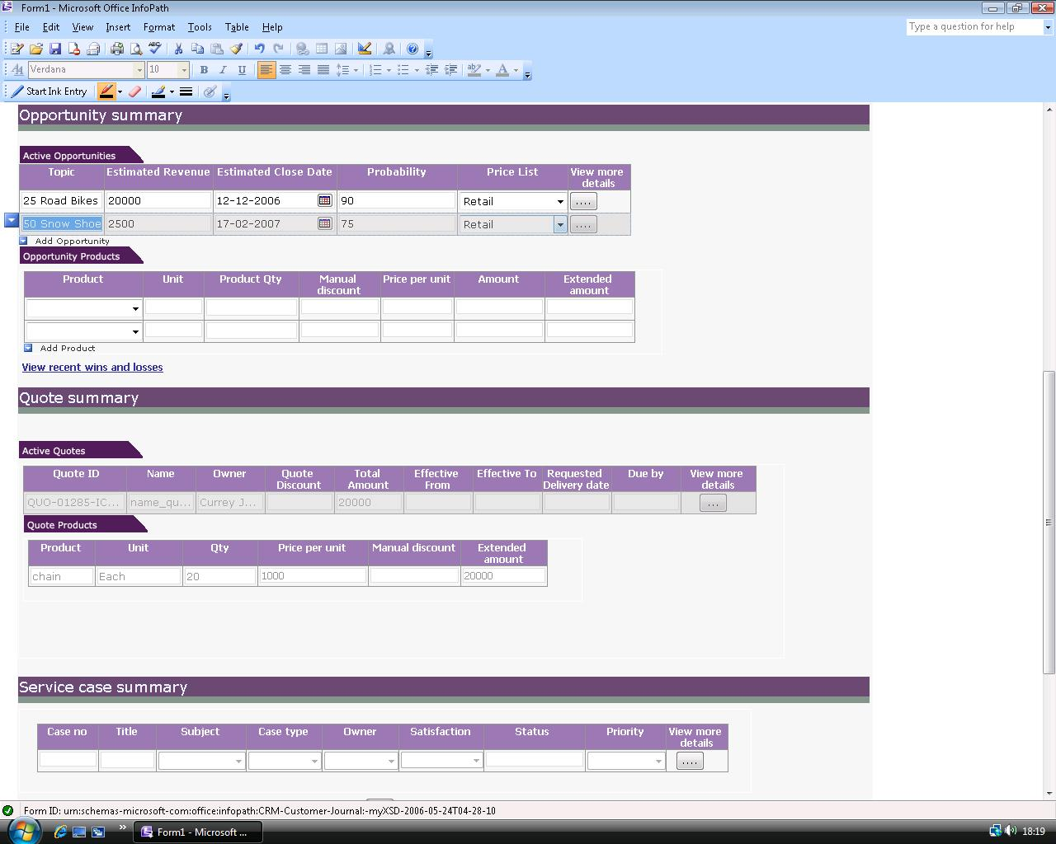
You can similarly add or edit service requests, quotations and customer profile data in the form. These changes can be updated in Microsoft Dynamics CRM once you are reconnected to your company network. Fields like ‘Service Request Number’, whose values are automatically set by Microsoft Dynamics CRM are not editable offline and are filled automatically once you synchronize the changes with Microsoft Dynamics CRM.
Taking Notes
You can use the Customer Journal to save and view the meeting notes for last 5 meetings with the customer. To see previous meeting notes, click on the View Previous meeting notes link in the form. The last five meeting notes are collated vertically and presented in a read-only panel in this section. To add new notes, click Add notes link. Once you have finished adding new notes, fill in the Subject, Venue, Date and Attendees fields of this section. When you synchronize the form’s contents with Microsoft Dynamics CRM (as described in the next section), these new notes are saved in Microsoft Dynamics CRM as notes attached to the customer account.
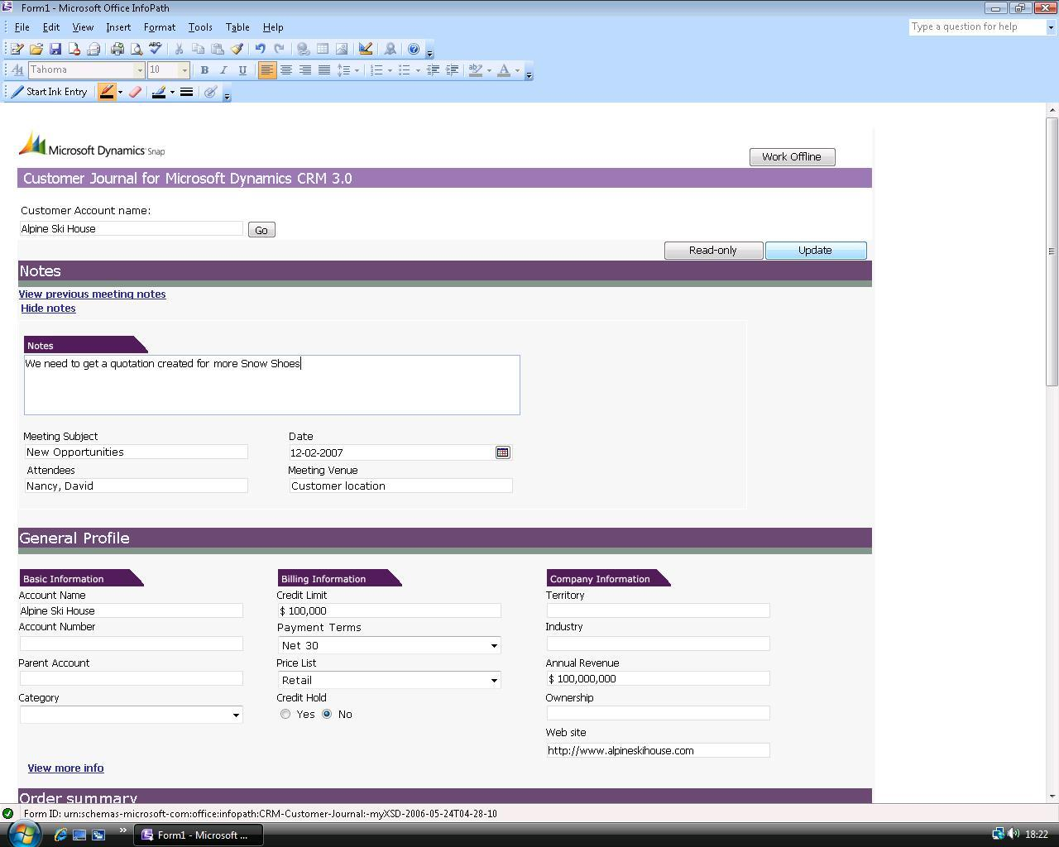

SYNCHRONIZING WITH MICROSOFT DYNAMICS CRM
Once you are back from the meeting, open the saved InfoPath form where you made the changes during the meeting and click Connect to CRM button and then click Update. A pop-up dialog opens, summarizing the changes made since the last refresh. You can review the changes and click Yes to confirm. The changes are updated in the Microsoft Dynamics CRM system.
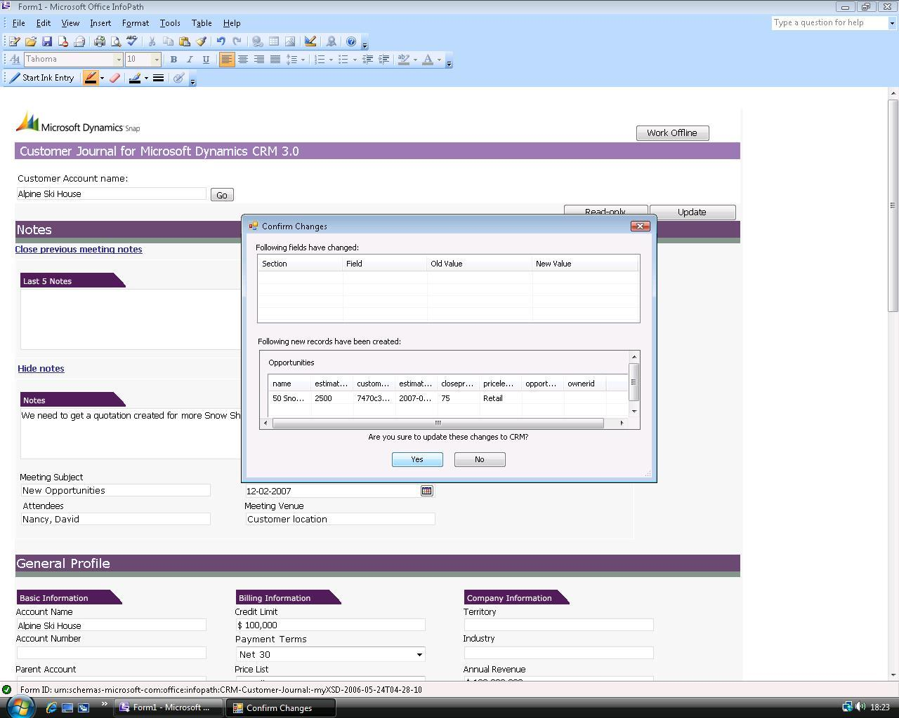

HIGH LEVEL ARCHITECTURE
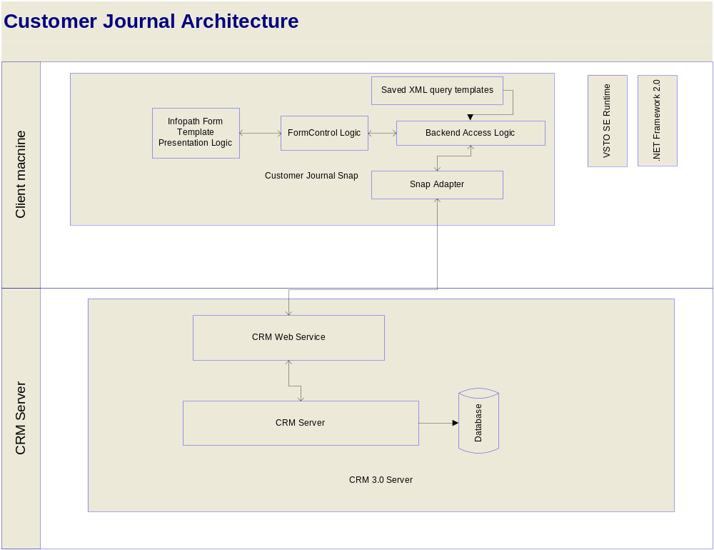

After you install the Microsoft VSTO 2005 SE Runtime and run the Customer Journal Snap-in installer, it copies the Microsoft Office InfoPath form template to the machine and registers it. InfoPath now recognizes the form template and can run the form-control customizations embedded in it.
When the user opens the Customer Journal Snap-in InfoPath form and connects to the Microsoft Dynamics CRM system, a new connection is made to Microsoft Dynamics CRM via Microsoft Dynamics CRM Web-Services API. The Snap Adapter is just a shim that provides a simple interface to Microsoft Dynamics CRM instance specified during setup. When the user searches for a specific customer’s information saved in Microsoft Dynamics CRM, the Web Service is queried using the XML queries saved in the InfoPath Form XML. The details for the customer are retrieved and bound to fields on the form as per defined schema. The user can now disconnect from Microsoft Dynamics CRM instance and take data offline. When data in InfoPath form fields changes or new fields are added, the corresponding field(s) are marked dirty. When update button is clicked, a custom action is fired in InfoPath that looks at all dirty fields in all the sections of the form and updates the corresponding entries in Microsoft Dynamics CRM system.

PRE-Requisites
- Microsoft Office 2007 should be installed, along with all the latest updates, and Microsoft Outlook should have been run at least once on the local machine
- The user should be a local admin on the machine and should have permissions and access to the Microsoft Dynamics CRM 3.0 server
- Microsoft .NET Framework 2.0 should be installed on the system
- Microsoft VSTO 2005 SE Runtime should be installed on the system
For more details on the pre-requisites and configuration requirements, please refer the installation guide in the setup package.

The information contained in this document represents the current view of Microsoft Corporation on the issues discussed as of the date of publication. Because Microsoft must respond to changing market conditions, this document should not be interpreted to be a commitment on the part of Microsoft, and Microsoft cannot guarantee the accuracy of any information presented after the date of publication.
This White Paper is for informational purposes only. MICROSOFT MAKES NO WARRANTIES, EXPRESS, IMPLIED, OR STATUTORY, AS TO THE INFORMATION IN THIS DOCUMENT.
Complying with all applicable copyright laws is the responsibility of the user. Without limiting the rights under copyright, no part of this document may be reproduced, stored in or introduced into a retrieval system, or transmitted in any form or by any means (electronic, mechanical, photocopying, recording, or otherwise), or for any purpose, without the express written permission of Microsoft Corporation.
Microsoft may have patents, patent applications, trademarks, copyrights, or other intellectual property rights covering subject matter in this document. Except as expressly provided in any written license agreement from Microsoft, the furnishing of this document does not give you any license to these patents, trademarks, copyrights, or other intellectual property.

© 2006 Microsoft Corporation. All rights reserved.
Microsoft, the Microsoft Dynamics Logo, 2007 Microsoft Office System, BizTalk, Dexterity, FRx, Microsoft Dynamics, SharePoint, Visual Basic, Visual C++, Visual SourceSafe, Visual Studio, Windows, and Windows Server are either registered trademarks or trademarks of Microsoft Corporation, FRx Software Corporation, or Microsoft Business Solutions ApS in the United States and/or other countries. Microsoft Business Solutions ApS and FRx Software Corporation are subsidiaries of Microsoft Corporation.
Microsoft Dynamics is a line of integrated, adaptable business management solutions that enables you and your people to make business decisions with greater confidence. Microsoft Dynamics works like and with familiar Microsoft software, automating and streamlining financial, customer relationship and supply chain processes in a way that helps you drive business success.

www.microsoft.com/dynamics

